**ESP Infotainment System**

**User Manual**

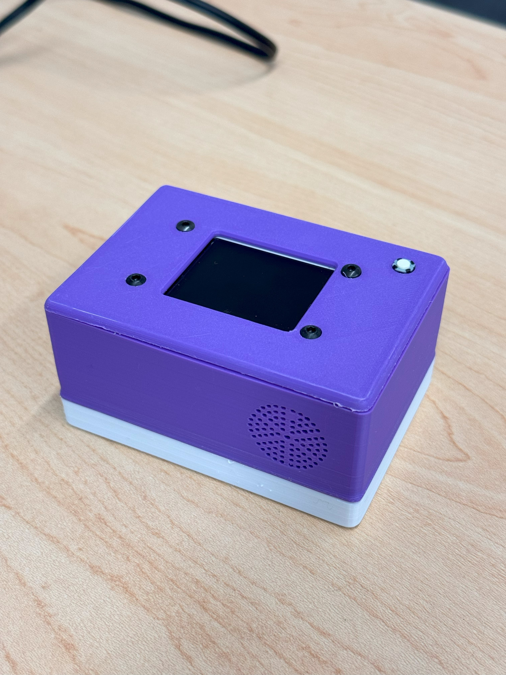

**Thank you for using the system, I really appreciate it!**

**INDEX**

1. **General System Interface**
2. **How To Operate**
3. **Transferring Media**
4. **Software Updates**
5. **Issues/Glitches**
6. **Contact Information**

**General System Interface**

The system in has four interaction points.

1. ON/OFF Switch
2. Push Button
3. SD Card Slot
4. USB Type C Port

**ON/OFF Switch** is used to turn the system ON or OFF.

**Push Button** is used to operate the system.

**SD Card Slot** Lets the user plug in an SD card to play media files.

The **USB Type C** Port lets the user charge the device.

The figure below highlights the four interaction points:

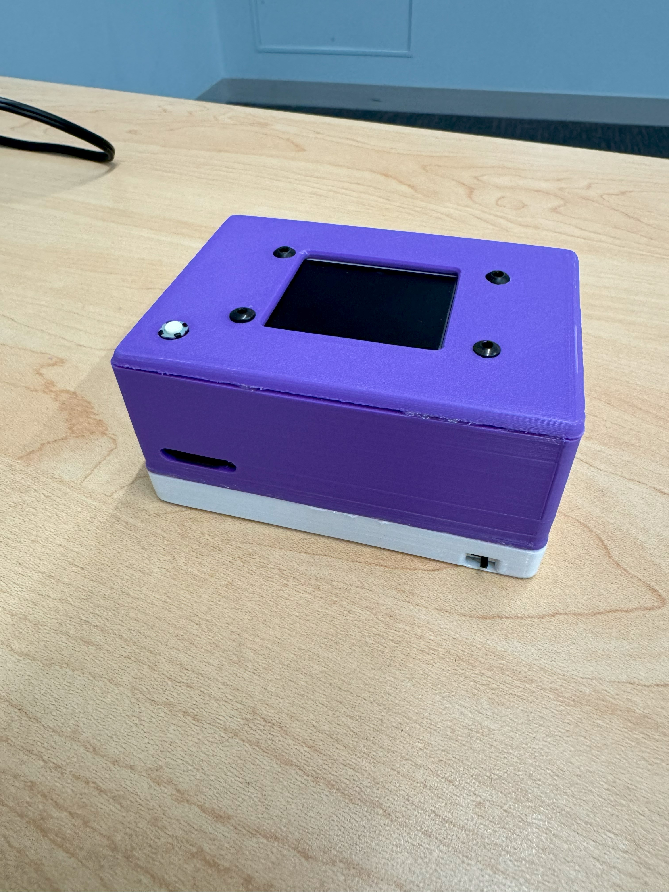 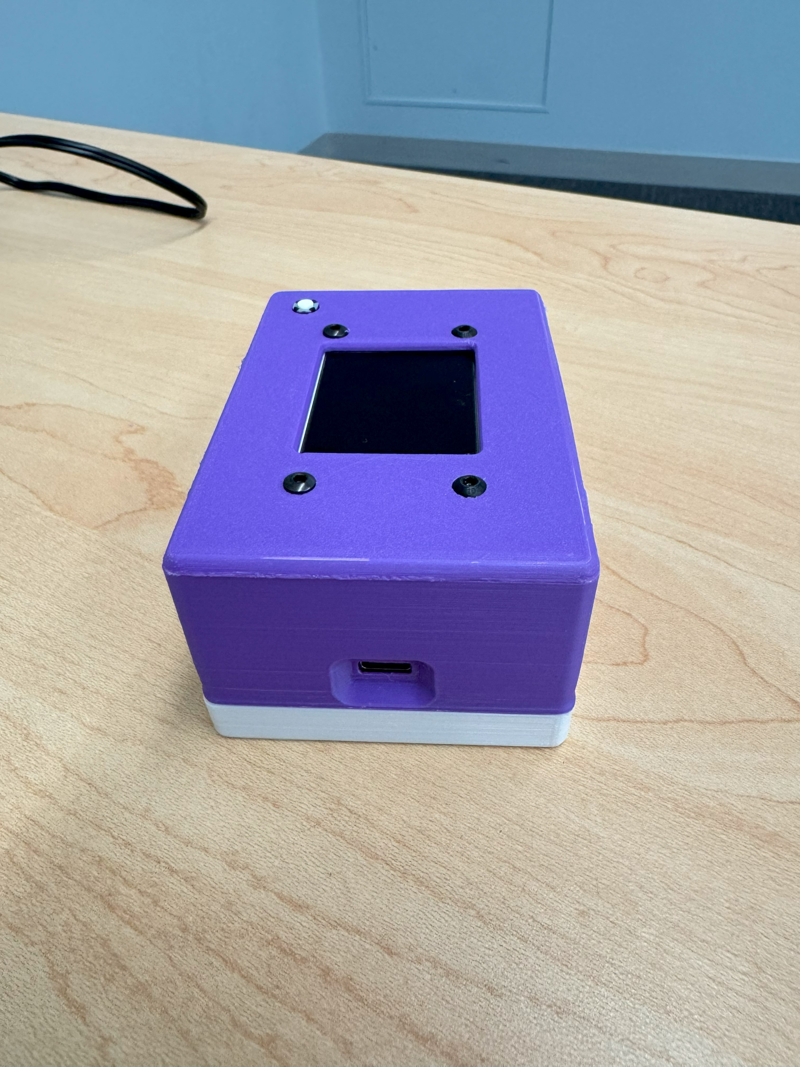

System Interaction points

**How To Operate**

The system is controlled via the push button. There are four press gestures supported:

1. Single Press
2. Double Press
3. Hold Press
4. Long Hold Press

Upon successful startup, you will be greeted with the initial screen. Shown below:

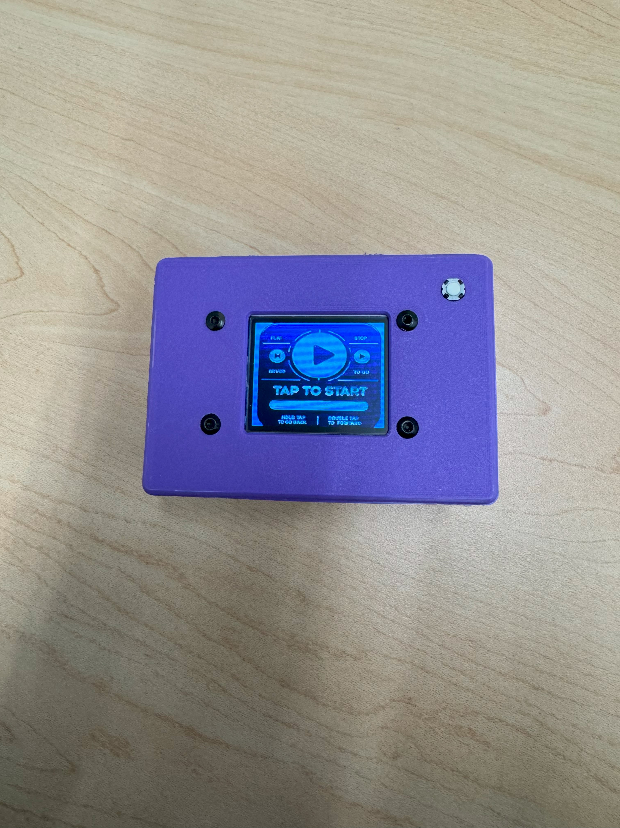  
  
1. From here you can start the media playback by Single Press.

2. To pause the playback, Single Press the button again.

3. While the media is stopped or paused, the user can go to the next or

previous file by giving a Double Press or Hold Press respectively.

4. If the state is stopped or pause, on giving a Long Hold Press, the system

displays information. A sample is shown below.

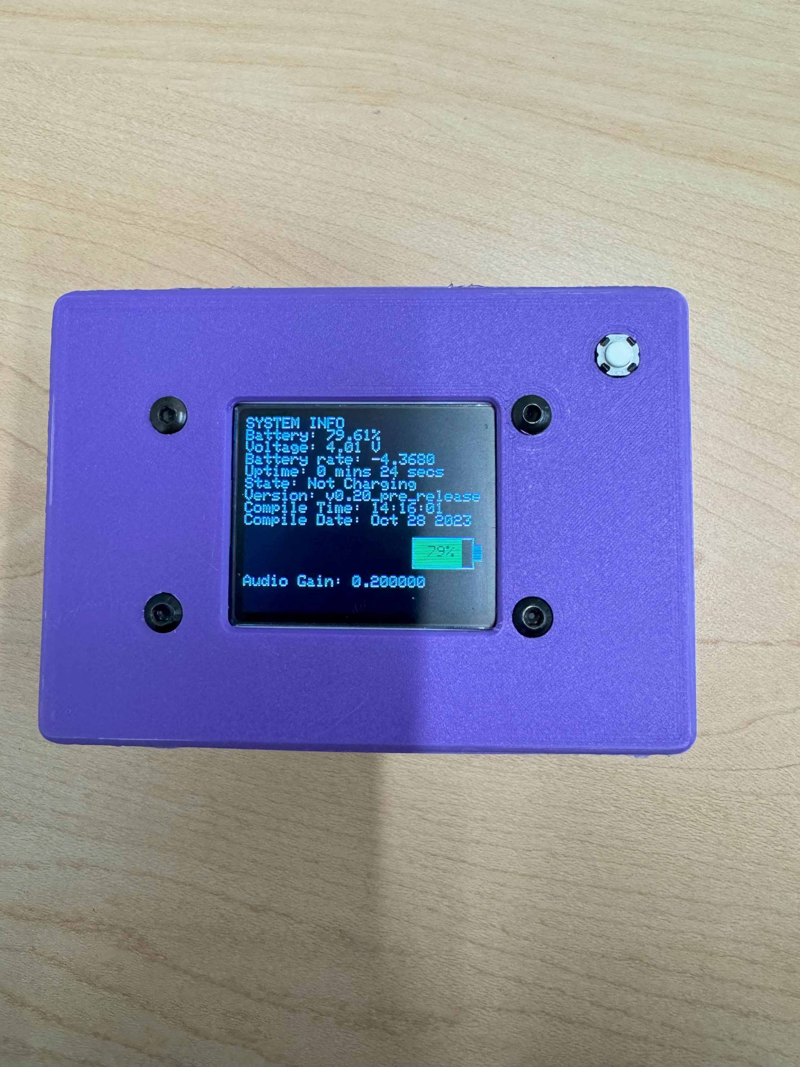

5. You can customize some system options by changing parameters inside

the SD card. The config fields are stored inside the “Config” Directory

inside the SD card. Here is a list of options you can change:

1. Audio Gain: A decimal number between 0 – 1.0
2. AutoPlay: A value of 1 or 0. Cycles to the next media file
3. Loop: A value of 1 or 0. If enabled loops the current media file.

**Transferring Media**

If you have a media player, then chances are that you want to add your own files, well you can use any .mp4 files. (GIFs or audio only files will need to be converted into .mp4 to be used as of now.)  
  
I have made a simple program that converts .mp4 video files into the supported media format by the system. It requires ffmpeg to run. To help further, I have made another program that helps you install ffmpeg on your computer (Windows support only). The following steps will walk you through the process.

1. You need FFMPEG to convert the videos.
2. Get it from here: <https://ffmpeg.org/download.html>
3. Use these commands in ffmpeg:
4. ffmpeg -i input.mp4 -ar 44100 -ac 1 -q:a 9 media.mp3
5. ffmpeg -i input.mp4 -vf "fps=24,scale=160:128:flags=lanczos" -q:v 9 media.mjpeg
6. Replace the "input.mp4" with you file name. To execute this, you either need to be in the bin folder for ffmpeg or have it in you PATH environment.
7. To make you life easier, I have made .EXE files with GUI to help you do this. WINDOWS ONLY
8. In the deploy folder, open the executables folder.
9. If FFMPEG is never used before, then download it. Use the link above. Remember where you download it and extract the archive.
10. Now run the "setup_ffmpeg.bat" script to "install" ffmpeg in your system PATH. If ffmpeg is already on you path, then skip. The script will ask you the location of the bin folder. There is a bin folder in the ffmpeg directory.
11. To check if ffmpeg is in you path, or to see if the above was successful, open a CMD prompt anywhere. and type this: "ffmpeg -version". You should get something about ffmpeg version. If ffmpeg is not in your path, then you will get an error most likely saying "'ffmpeg' is not recognized as an internal or external command, operable program or batch file.". If this is the case even after running the script, then please feel free to contact me. Info at the bottom.
12. Once ffmpeg is "installed" simply run the "ConvertVideos.exe" file to convert your videos. Follow the standard naming format for the files. Name the files as “media” and the numbering will start from you desired number. If it’s the first time, then use 1. (Numbering has to be greater than 0 and has to be continuous, 1 2 3 5 6 -> wont work.)
13. Once the videos are converted, copy all the output files (you should have folders with names as numbers) and paste it inside the Videos directory in the SD card.
14. Reboot the system and it should now start playing the media from number 1.

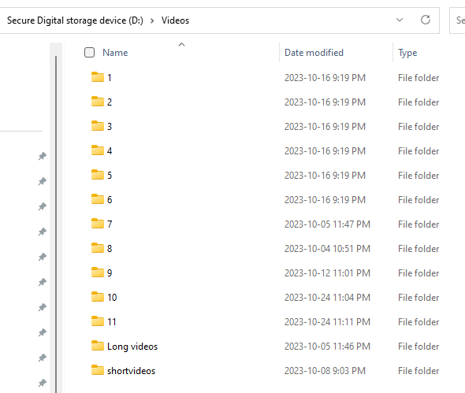

This is how the media files should be copied into the SD card. All other folders will be ignored

**Software Updates**Over time, there will be new features added, bugs fixed. To update your system’s software, simply boot the system in the Software update mode.   
  
This can be done by holding the Push Button before turning ON the system and keeping it pressed until you see the Software Update mode screen. It is shown below:

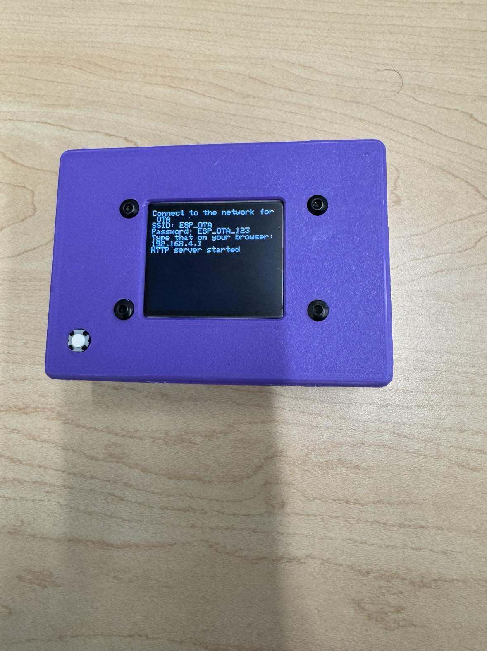  
  
Follow the on-screen instructions and connect to the System WiFi hotspot. Then you can enter the IP address in your browser or scan the QR code to access the Update webpage. Follow the instructions there to upload you new firmware.   
  
Upon successful completion of the software upgrade, the system will reboot automatically.

DO NOT TURN OFF THE BOARD MID UPDATE, THIS MIGHT MAKE IT UNUSABLE AND YOU WILL HAVE TO RETURN THE UNIT TO THE FACTORY TO REPAIR!!!!

**Issues/Glitches**

Here is a list of known issues that are currently in the system:

1. Media playback hang/stop during fast forward.
2. System Restart mid switching.

To fix these issues, or any issue if the system hangs, simply power cycle the system by flipping the switch to OFF and then ON. This will fix 99% of the errors.   
  
Based on my testing and development, the system is vulnerable to glitches when media is switched mid playback. Consider disabling LOOP functionality and switch the media after it has stopped playing. Autoplay function also works to minimise glitches.

**Contact Information**Hi! I can be reached via emails. My email is:  
  
[nischayjoshi2312@gmail.com](mailto:nischayjoshi2312@gmail.com)

Thank you for reading the document so far, enjoy the System. I hope it will be useful to you!